Azure Kubernetes Service
Azure Kubernetes is a fully managed container management service by Microsoft Azure Cloud Service provider , that offers serverless continuous integration and continuous deployment experience

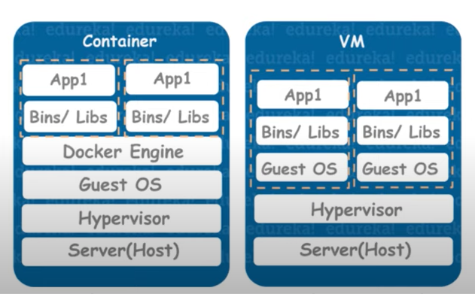

Need for Kubernetes

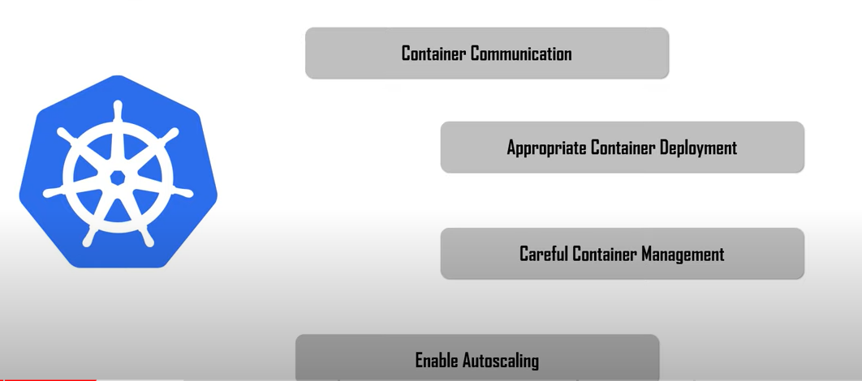

Kubernets is an open source Container Management tool which automates container deployment , container scaling and container load balancing.

Kubernetes Architecture

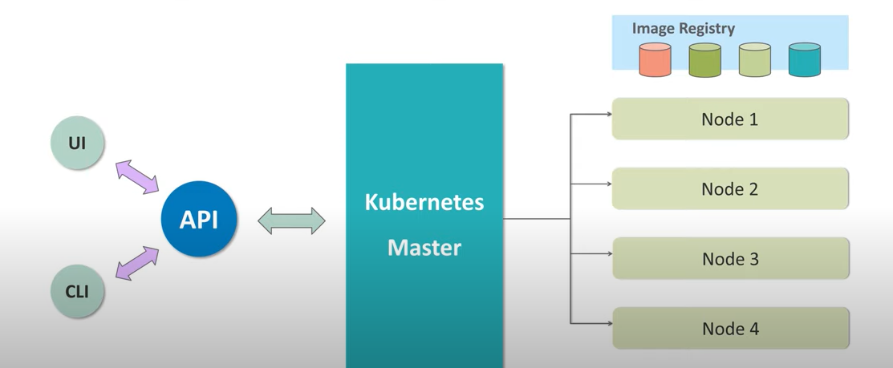

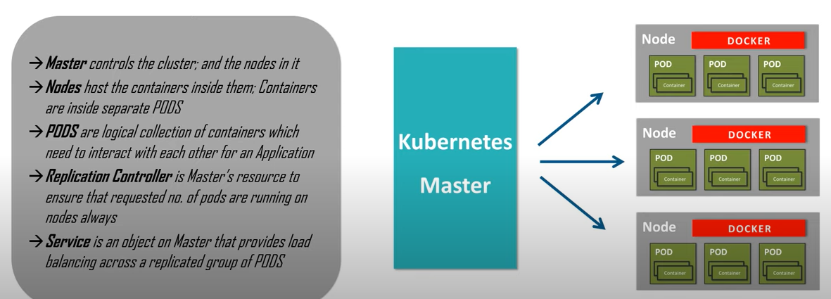

Working of AKS

Microsoft charges only for the worker nodes

Azure manages the master node

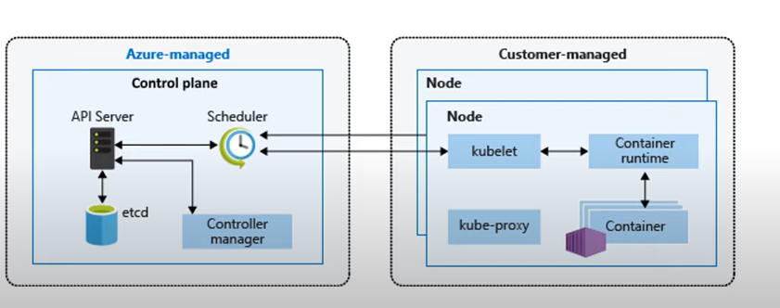

Etcd maintains the state of the Kubernetes cluster

Customer managed

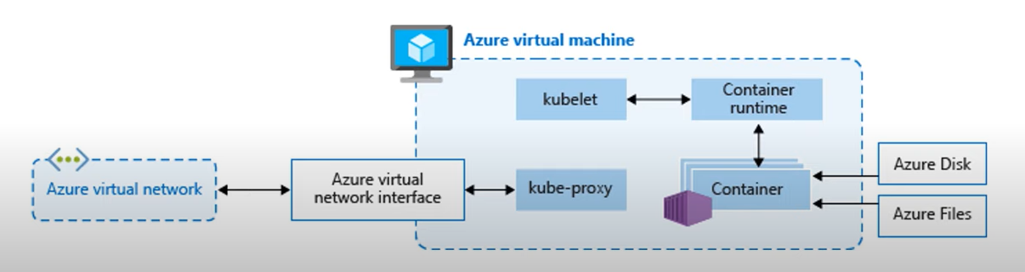

Vehicles safety with AKS

Create Kubernetes Cluster

Cluster name , Region , Availability zones , Kubernetes version
Node count

az aks get-credentials –resource-group RGForDemo –name KubeCluster

kubectl get nodes
nano azure-vote.yaml
kubectl apply -f azure-vote.yaml
kubectl get service azure-vote-front –watch

